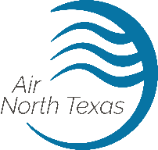

CLEAN AIR ACTION CHALLENGE 2024

APPLICATION
Company Name: Number of Employees: Contact Name: _ Contact Phone: _ Contact Email:
The City of Grand Prairie is challenging your company to take part in the Clean Air Action Challenge by pledging to do one thing for clean air at https://www.airnorthtexas.org/cleanairactionday and by creating new innovative clean air initiatives to encourage further employee participation.
Instruct your employees to take the Clean Air Action Pledge at www.AirNorthTexas.org/CleanAirActionDay. To ensure that pledges count towards your totals, your employees must write your company name in the provided box. The City will receive pledge totals from Air North Texas.
Submit your application to CleanAir@gptx.org or to estraw@gptx.org. Application and all other materials for your entry are due Friday, June 7, 2024. For more information and to view a presentation that includes ideas for initiatives, go to www.gptx.org/Clean Air. If you have questions, please email estraw@gptx.org or contact Environmental Quality at 972-237-8055.

Initiatives completed:
⃝ Encouraged employee pledges
⃝ Sent daily emails on clean air
⃝ Employee education
⃝ Created a Prize Patrol
⃝ Challenged employees to compete
⃝ Created a carpool parking spot
⃝ Other:
⃝ Other:
⃝ Other:
⃝ Other:
⃝ Other:
⃝ Other:
⃝ Other:

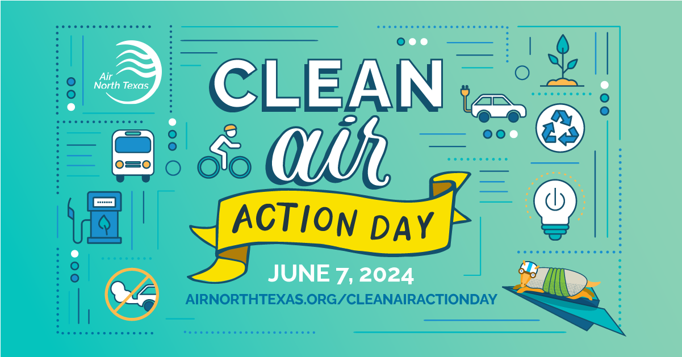

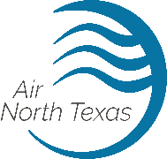
Grand Prairie is a regional partner with Air North Texas, a non proﬁt organization through NCTCOG, to promote a consistent air quality message and increase public awareness to improve air quality.

Why Have the Challenge?
The 10-county DFW area is nonattainment for ozone aﬀecting local businesses operations with air permits, restrictions on operations and estimated $270 billion annual loss in economic output.

The Clean Air Action Challenge
The City of Grand Prairie is challenging your company to take action to reduce air pollution.

The Rules of the Challenge
- Encourage your employees to take the Clean Air Action Pledge at
www.AirNorthTexas.org/CleanAirActionDay
- Create or adopt new creative clean air initiatives to encourage employee participation.
- Complete and submit an application to estraw@gptx.org by Clean Air Action Day on Friday, June 7, 2024. Application and additional information about the Challenge can be found at www.gptx.org/CleanAir.

Winners
Winners of the Clean Air Action Challenge will be presented with an award at our annual awards luncheon.

Go to www.gptx.org/CleanAir for more information and the application. If you have questions, email CleanAir@gptx.org or contact Environmental Services at 972-237-8055.

